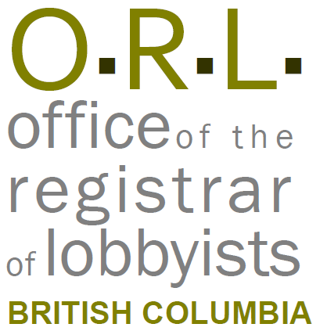
Tracking Lobbying Activities: Consultant Lobbyists
It is a legal requirement that accurate information be entered in the BC Lobbyists Registry. Providing inaccurate or incomplete information in the Lobbyists Registry is a compliance issue and may result in an investigation being commenced by the Registrar.
Notice
This document is for information purposes only and does not constitute a decision or finding by the Registrar of Lobbyists for British Columbia or their delegates. This guidance does not affect the powers, duties or functions of the Registrar of Lobbyists, or their delegates, regarding any investigation or other matter under the Lobbyists Transparency Act, respecting which the Registrar and their delegates will keep an open mind. Responsibility for compliance with the Lobbyists Transparency Act remains with each client, lobbyist, and public office holder.

Name of client: Click here to enter text.
Lobbying Activities
For each lobbying activity in the preceding month on behalf of this client, you will be required to file a Monthly Return and report the following information in the Lobbying Activity Report. If there was more than one lobbying activity on behalf of this client in the preceding month, add each lobbying activity separately to the chart below. You may file one or more Lobbying Activity Reports for each client, each month. If you file more than one Lobbying Activity Report for this client, you will enter information about each lobbying activity separately.
Note: For Subject matter of the lobbying activity, and Intended outcome of the lobbying activity, the filer will choose from drop-downs in the registry’s Lobbying Activity Report screens.
Date of the lobbying activity: | Name and position title of the senior public office holder(s) who was the object of the lobbying activity. Include name of Ministry or Prov entity: | Details of the lobbying activity. Summarize matters discussed, and explain the decision or outcome, or the name of the policy, program or legislation you were trying to influence:
Click here to enter text. | Click here to enter text. | Click here to enter text.
Click here to enter text. | Click here to enter text. | Click here to enter text.
Click here to enter text. | Click here to enter text. | Click here to enter text.

Changes to the information in the Registration Return
Particulars of any change in the preceding month to the information in the Registration Return:
Click here to enter text.
Political, sponsorship and recall contributions
The Lobbyists Transparency Act requires that consultant lobbyists declare whether they, or a client, made any political, sponsorship, and recall contributions, on or after the date the writ was issued for the last provincial election.
The rule that corporations, union, and other organizations are not permitted to make political or sponsorship contributions came into effect November 30, 2017. After November 30, 2017, only a client who is an “eligible individual” who resides in BC, and is a Canadian citizen, or has been granted permanent resident status by the Government of Canada, would be allowed to make a political or sponsorship contribution.
The rule that corporations, unions, and other organizations are not permitted to make recall contributions came into effect November 8, 2018. After November 8, 2018, only a client who is an “eligible individual” who resides in BC, and is a Canadian citizen or has been granted permanent resident status by the Government of Canada, would be allowed to make a recall contribution.
For further information, see the ORL’s guidance document on Reporting Political, Sponsorship, and Recall Contributions.
- Has the consultant lobbyist or client made, since the date the writ was issued for the last provincial election, a political contribution to an MLA who is the object of lobbying activity, or to that MLA’s political party or constituency association?

Client ☐Yes ☐no
Consultant Lobbyist ☐Yes ☐No

- Has the consultant lobbyist or client made, since the date the writ was issued for the last provincial election, a sponsorship contribution to a third-party sponsor for the purpose of sponsoring election advertising that directly promotes the election of an MLA who is the object of lobbying activity, or to that MLA’s political party?

Client ☐Yes ☐No
Consultant Lobbyist ☐Yes ☐No

- Has the consultant lobbyist or client made, since the date the writ was issued for the last provincial election, a recall contribution to an MLA who is the object of lobbying activity, or to that MLA’s political party or constituency association?

Client ☐Yes ☐No
Consultant Lobbyist ☐Yes ☐No
Gifts
Has the consultant lobbyist promised or given a gift or other benefit, in the preceding 12 months, to a public office holder being lobbied?
☐Yes ☐No If yes:
Date gift was given or promised: | Name of the public office holder: | Description of the gift or benefit including value: | Circumstances under which gift or benefit was promised or given:
Click here to enter text. | Click here to enter text. | Click here to enter text. | Click here to enter text.
Click here to enter text. | Click here to enter text. | Click here to enter text. | Click here to enter text.

