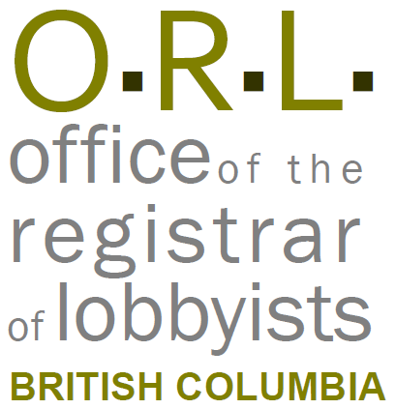

Notice
This document is for information purposes only and does not constitute a decision or finding by the Registrar of Lobbyists for British Columbia or their delegates. This guidance does not affect the powers, duties or functions of the Registrar of Lobbyists, or their delegates, regarding any investigation or other matter under the Lobbyists Transparency Act, respecting which the Registrar and their delegates will keep an open mind. Responsibility for compliance with the Lobbyists Transparency Act remains with each client, lobbyist, and public office holder.

Tracking Lobbying Activities: In-house Lobbyists
It is a legal requirement that accurate information be entered in the BC Lobbyists Registry. Providing inaccurate or incomplete information in the Lobbyists Registry is a compliance issue and may result in an Investigation being commenced by the Registrar.
Please provide accurate information in response to the questions below, and return the completed questionnaire to the person preparing the Monthly Returns (which include Lobbying Activity Reports) on behalf of your organization.
The information below will become public information once submitted to the Office of the Registrar of Lobbyists for BC. Email addresses will not be publicly available except where noted.
Please ensure that the person responsible for filing and updating the Monthly Returns on behalf of your organization is kept advised of any changes to the information set out below.
Lobbying Activities
Provide the following information for each lobbying activity in the preceding month. If there was more than one lobbying activity in the preceding month, complete the information for each lobbying activity separately.
Note: for Subject matter of the lobbying activity, and Intended outcome of the lobbying activity, filer will choose from the drop-downs in the Lobbying Activity Report screens.
Date of the lobbying activity: | Name and position title of the senior public office holder(s) who was the object of the lobbying activity. Include name of Ministry or Prov entity: | Names of the lobbyists who participated in the lobbying activity: | Details of the lobbying activity. Summarize matters discussed, and explain the decision or outcome, or the name of the policy, program or legislation you were trying to influence:
Click here to enter text. | Click here to enter text. | Click here to enter text. | Click here to enter text.
Click here to enter text. | Click here to enter text. | Click here to enter text. | Click here to enter text.
Click here to enter text. | Click here to enter text. | Click here to enter text. | Click here to enter text.

Changes to the information in the Registration Return
Note any changes to the information currently in the Registration Return
Click here to enter text.
Political, sponsorship and recall contributions
The Lobbyists Transparency Act requires that organizations declare whether political, sponsorship and recall contributions have been made by any in-house lobbyists, on or after the date the writ was issued for the last provincial election. For further information, see the ORL’s guidance document on Reporting Political, Sponsorship, and Recall Contributions.
- Has the in-lobbyist made, since the date the writ was issued for the last provincial election, a political contribution to an MLA who is the object of lobbying activity, or to that MLA’s political party or constituency association?
☐Yes ☐No

- Has the in-lobbyist made, since the date the writ was issued for the last provincial election, a sponsorship contribution to a third-party sponsor for the purpose of sponsoring election advertising that directly promotes the election of an MLA who is the object of lobbying activity, or to that MLA’s political party?
☐Yes ☐No

- Has the in-lobbyist made, since the date the writ was issued for the last provincial election, a recall contribution to an MLA who is the object of lobbying activity, or to that MLA’s political party or constituency association?
☐Yes ☐No

Gifts
Has the organization promised or given a gift or other benefit, in the preceding 12 months, to a public office holder being lobbied?
☐Yes ☐No

If yes:
Date gift was given or promised: | Name of the public office holder: | Description of the gift or benefit including value: | Circumstances under which gift or benefit was promised or given:
Click here to enter text. | Click here to enter text. | Click here to enter text. | Click here to enter text.
Click here to enter text. | Click here to enter text. | Click here to enter text. | Click here to enter text.

